**CHANGES TO LANDING PAGE**

**Landing Page : https://astratechsystems.com/bettor/**

**The timer for Offer expiry should be from one end to another see the below image**



**The background for the header page should be complete black with the Graphic human face visible in the background see the below image**



**The Video frame should have a border either blue or some light color as seen in below image**



**Remove the two paragraphs from the current position as shown in the below image below**



**Remove the $9 line from the below image below**



**Remove the 60 number to 30 number from the below image below**



**Remove all the words underlined below as seen on the below image**

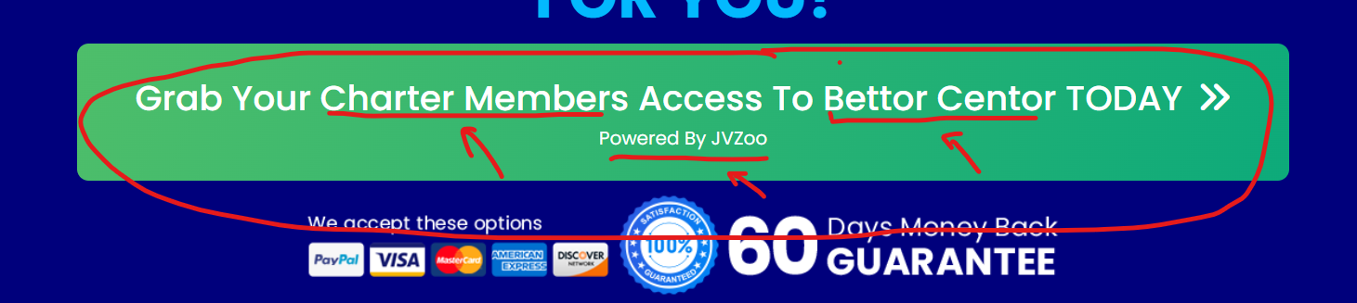

**Remove the 60 number to 30 number from the below image below**



**Remove the images from the below section as shown in the image below**

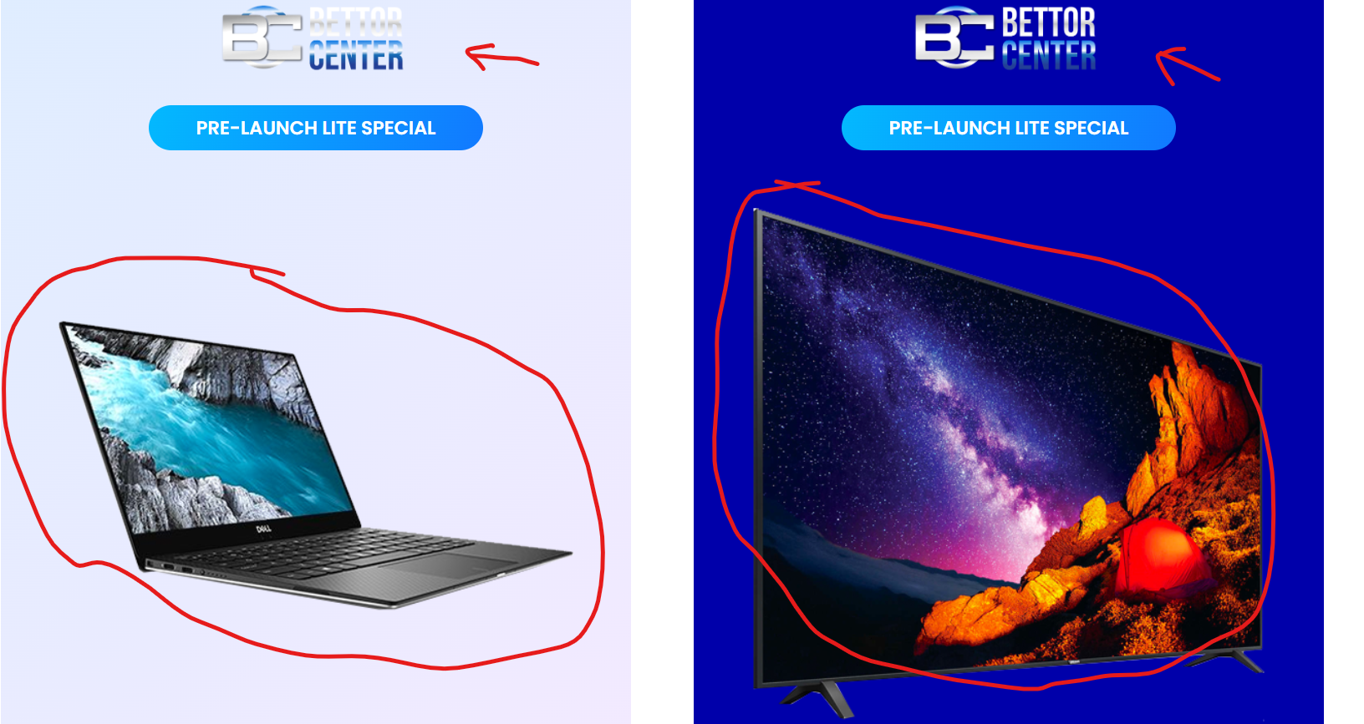

**Change the circled number $9 to $7.99 in the section for image below**

